## SQL

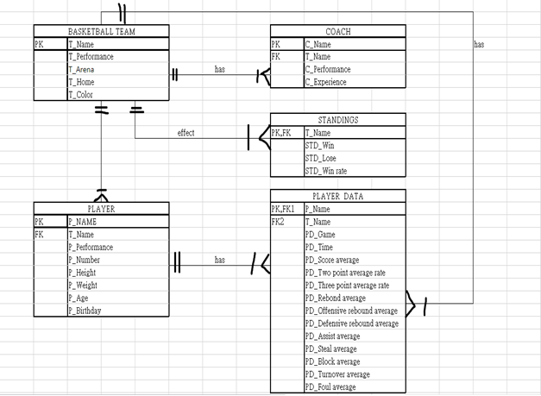

**介紹:**想做出一個籃球聯盟的球隊隊資料，以台灣的P.LEAGUE+籃球聯盟做為主題，有四支球隊，裡面包含了各隊主場、教練、球員、分析數據，主要目的可以快速查詢到所需資料。

**DATA DICTIONARY**

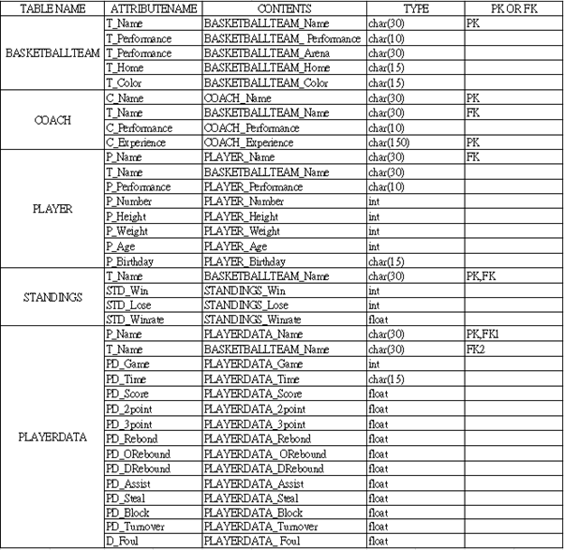

**正規化**

|  |  |
| --- | --- |
| **TABLE NAME** | **BASKETBALL TEAM** |
| **ATTRIBUTE** | **T_Name,T_Performance,T_Performance,T_Home ,T_Color** |
| **NOMALIZATION** | **符合單值(1NF)、部分相依(2NF)、直接關係(3NF)** |
| **REASON** | **每個ATTRIBUTE只與主鍵(T_Name)相依** |

|  |  |
| --- | --- |
| **TABLE NAME** | **COACH** |
| **ATTRIBUTE** | **C_Name,T_Name,C_Performance,C_Experience** |
| **NOMALIZATION** | **符合單值(1NF)、部分相依(2NF)、直接關係(3NF)** |
| **REASON** | **每個ATTRIBUTE只與主鍵(C_Name)相依** |

|  |  |
| --- | --- |
| **TABLE NAME** | **PLAYER** |
| **ATTRIBUTE** | **P_Name,T_Name,P_Performance,P_Number,P_Height,P_Weight,P_Age,P_Birthday** |
| **NOMALIZATION** | **符合單值(1NF)、部分相依(2NF)、直接關係(3NF)** |
| **REASON** | **每個ATTRIBUTE只與主鍵(P_Name)相依** |

|  |  |
| --- | --- |
| **TABLE NAME** | **STANDINGS** |
| **ATTRIBUTE** | **T_Name,STD_Win,STD_Lose,STD_Winrate** |
| **NOMALIZATION** | **符合單值(1NF)、部分相依(2NF)、直接關係(3NF)** |
| **REASON** | **每個ATTRIBUTE只與主鍵(T_Name)相依** |

|  |  |
| --- | --- |
| **TABLE NAME** | **PLAYERDATA** |
| **ATTRIBUTE** | **P_Name,T_Name,PD_Game,PD_Time,PD_Score,PD_2point,PD_3point,PD_Rebond,PD_ORebound,PD_DRebound,PD_Assist,PD_Steal,PD_Block,PD_Turnover,PD_Foul** |
| **NOMALIZATION** | **符合單值(1NF)、部分相依(2NF)、直接關係(3NF)** |
| **REASON** | **每個ATTRIBUTE只與主鍵(T_Name)相依** |

**Select**

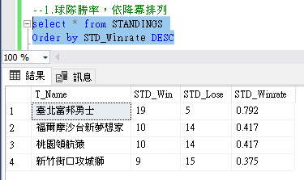

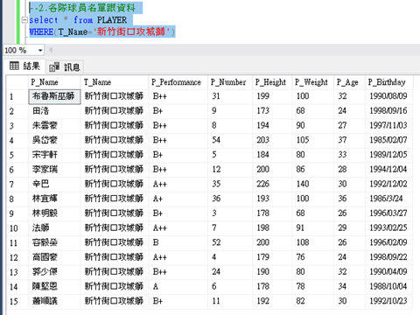

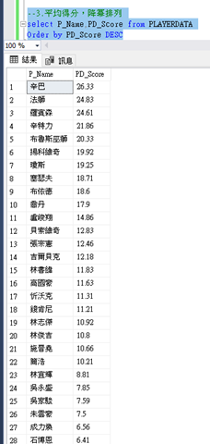

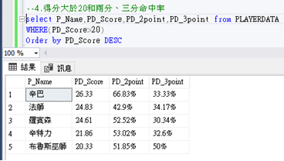

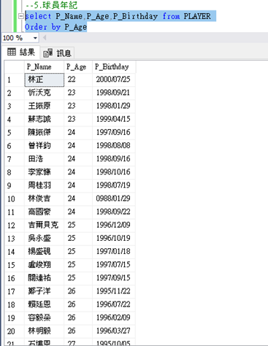

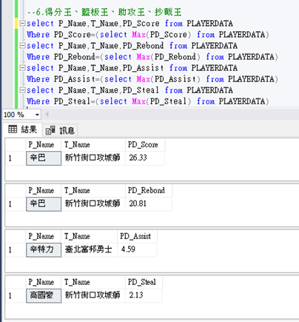

**資料庫圖表**

